|  |
| --- |
| PANDEMONIUM Game Instructions |
| Large rock formation in rocky landscape under blue sky |

|  |  |
| --- | --- |
| 12/07/2020 | By Group 4 |

This document is an overview of how to play the game “Pandemonium” including an overview of controls, basic concepts, and screenshots.

# **Basic Instructions**

Upon startup the following screen will be shown displaying the main menu of the game itself.

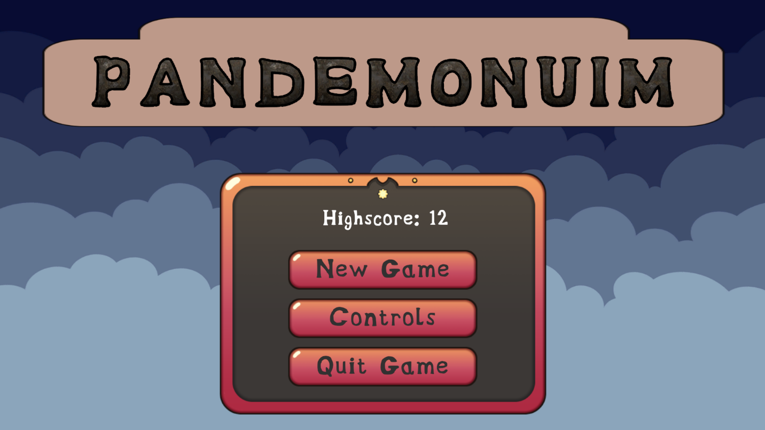

Here three options will be displayed, one to start the game, one to view the controls, and one to quit the game.

The controls page looks like the following:  
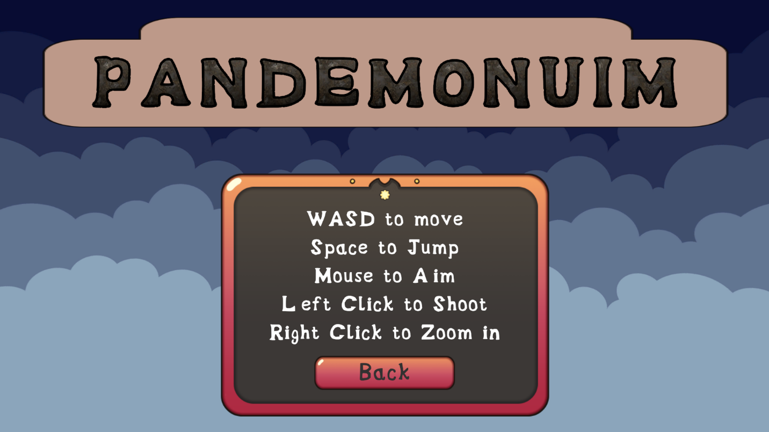

Most importantly, however, is when you select the new game options the following screen will appear:

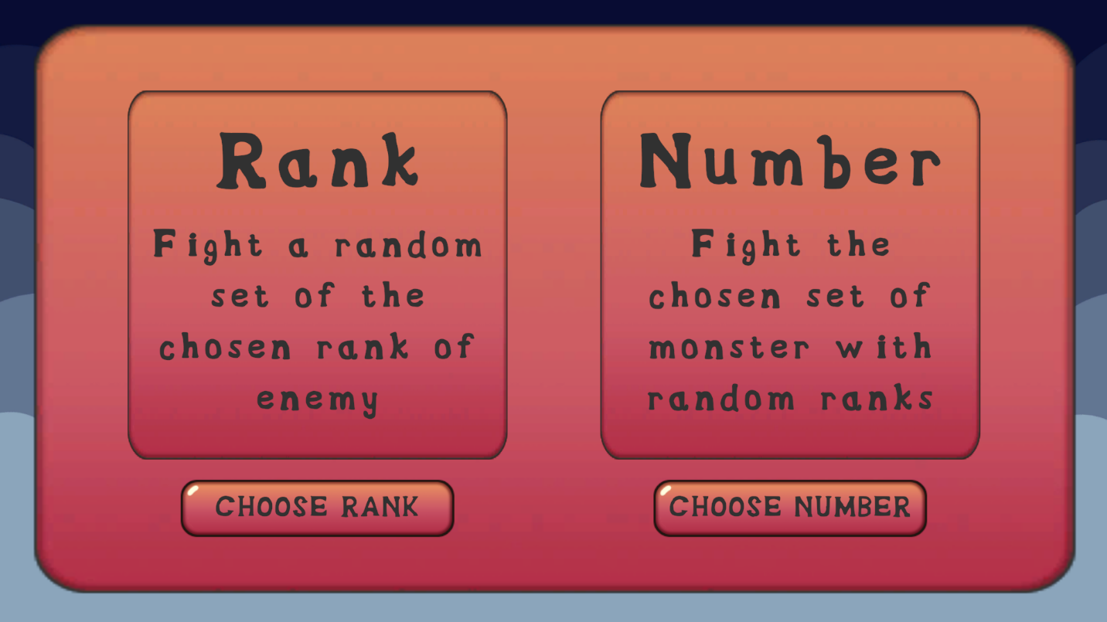

Here you can choose to fight monsters based on rank or number. If you choose rank then you are taken to the following screen:

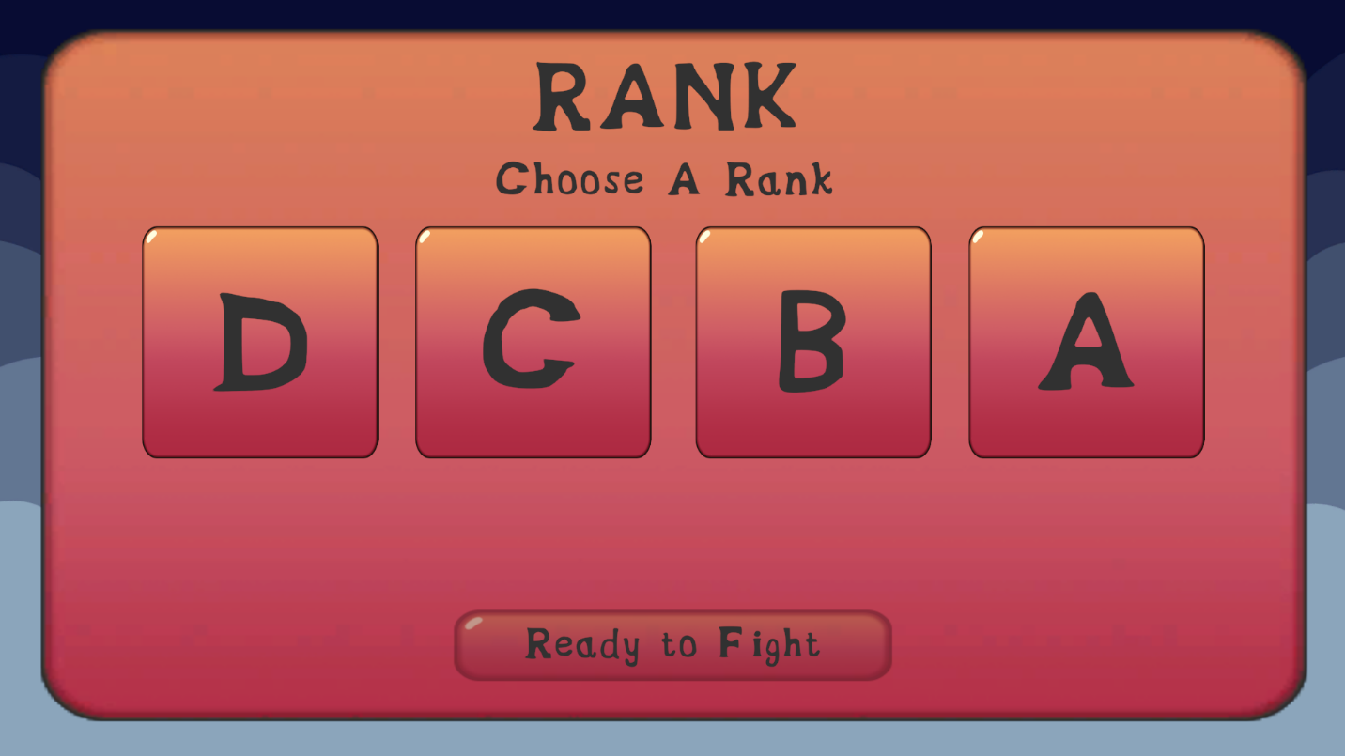

Here you can decide what rank to fight (D, C, B, A) and when you select Ready to Fight, you will be sent to the main game arena where you will fight a random number of monsters that are all of the rank chosen. Each rank consists of monsters of increased difficulty. Once the rank is selected, a bar will appear at the bottom which displays the experience point multiplier that the player will receive for fighting that rank:

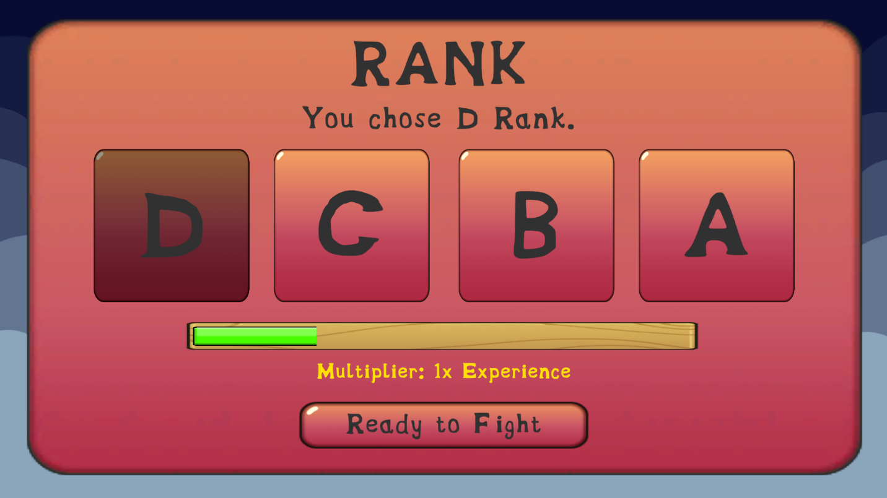

This multiplier obviously increases with the rank chosen.

Now, going backwards, if you chose to select by number, you will be faced with the following screen:

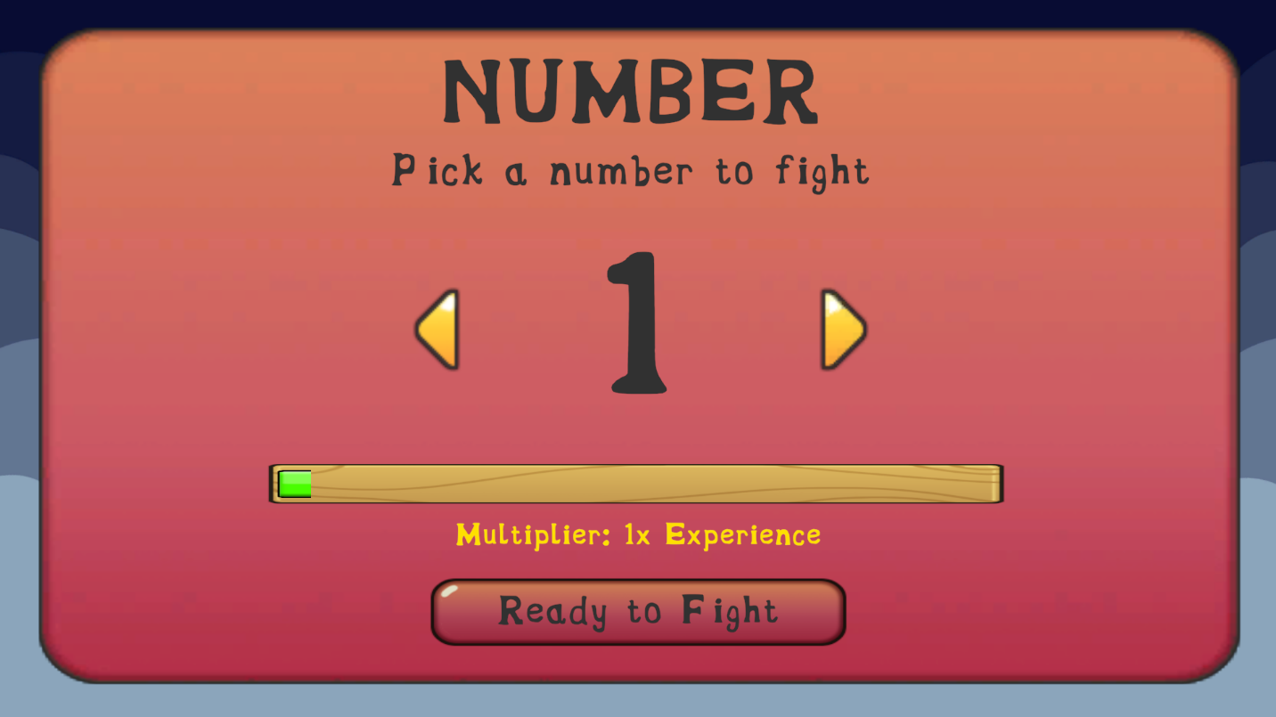

It is very similar to the rank screen, however, you will be faced with the option to select how many monsters to fight where all of them will be from a random rank (with weaker monsters being more likely early on, and stronger monsters more likely the farther you go). You can increase or decrease this number in order to fight more monsters and get a higher experience multiplier:  
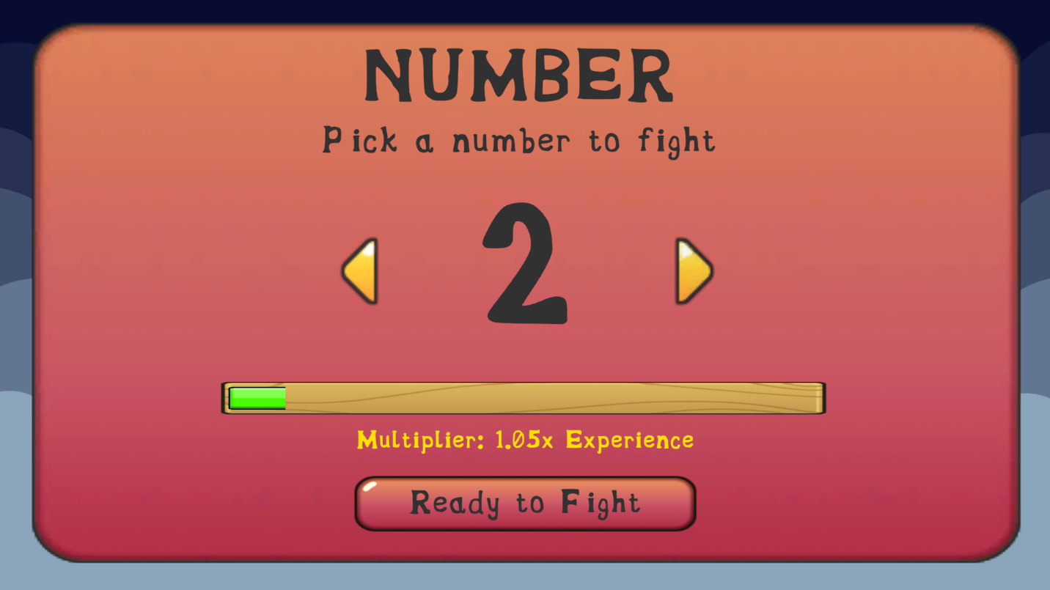

The main goal of this game is to defeat all of the monsters of all of the ranks and finally defeat the final boss – the S rank monster.

# **Basic Game and how they work**

Now, when you select Ready to Fight from either screen you will be sent to the main arena where the combat of the game takes place:

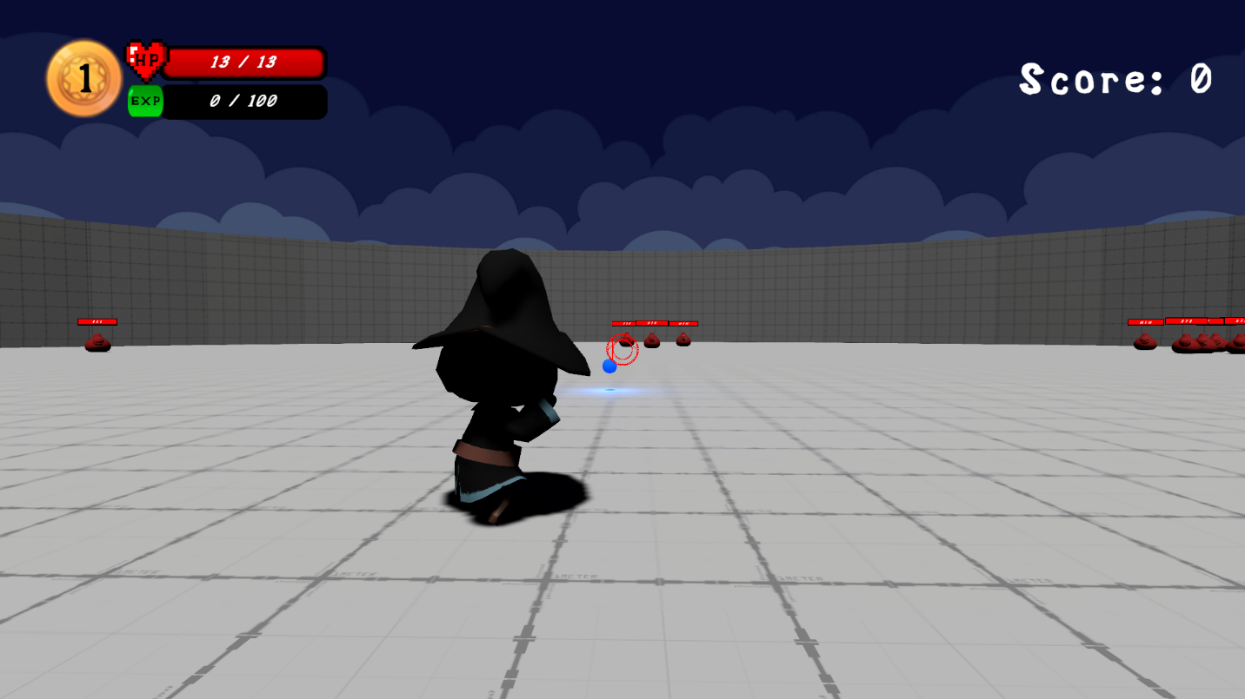

Here you will have your level, HP, and current EXP (experience) in the top left corner, and your current score in the top right (your overall high score will be saved at the main menu). The wizard character in the middle is you – the player, the red dot in the middle is your aiming crosshair, and the blue orb is the projectile fired by the wizard. Here is a list of the basic controls as listed in the controls menu:

Movement – WASD

Camera Movement/Aiming – Mouse Movement

Shooting Magic – Left Clicking

Open Menu for options/exit the game – Esc

If you are defeated in the game (your HP reaches 0 at any point) then you will be faced with the following screen:

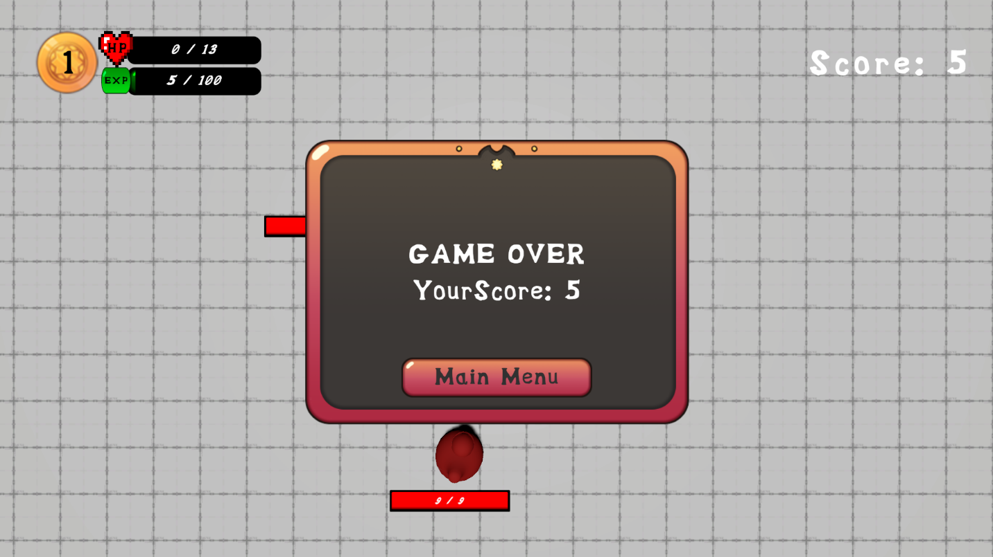

Here you will return back to the Main Menu where you can choose to start a new game.

Alternatively, if you defeat all of the monsters on the current stage you will be presented with the following screen:

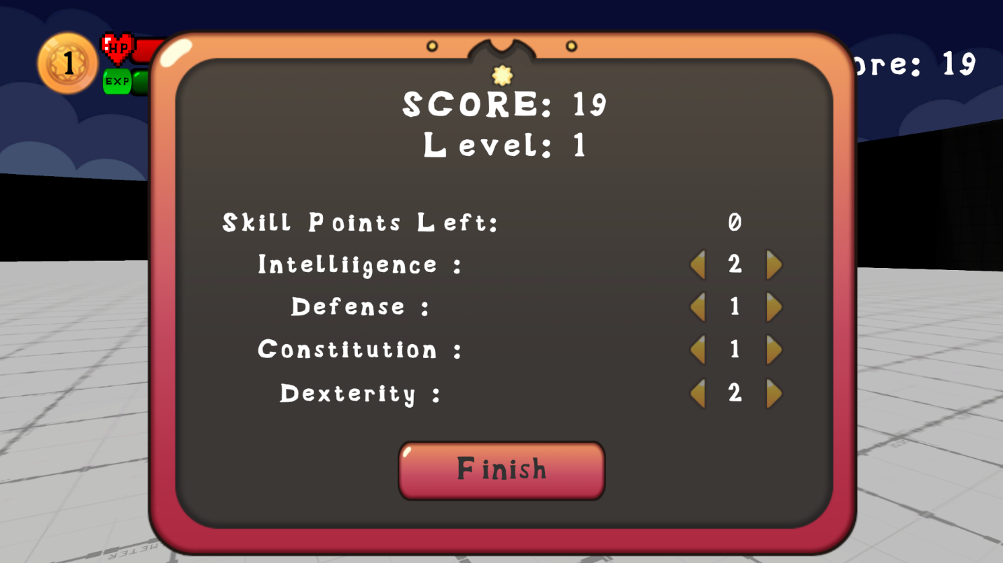

This screen will allow you to increase your overall stats. You will receive skill points dependent on the number of times you leveled up during your current stage. Here you can choose to put them into any of the four stats: Intelligence, Defense, Constitution, and Dexterity. Here is a list of what each stat does:

Intelligence: Intelligence increases both the Range and the damage of the magic projectile

Defense: Reduces overall damage taken

Constitution: Increases maximum health

Dexterity: Increases overall movement (magic projectile speed, speed of player, and decreases the delay between shots so projectiles can be fired faster)

Finally, once your stats have been selected a portal will appear within the stage that the player can walk through:  
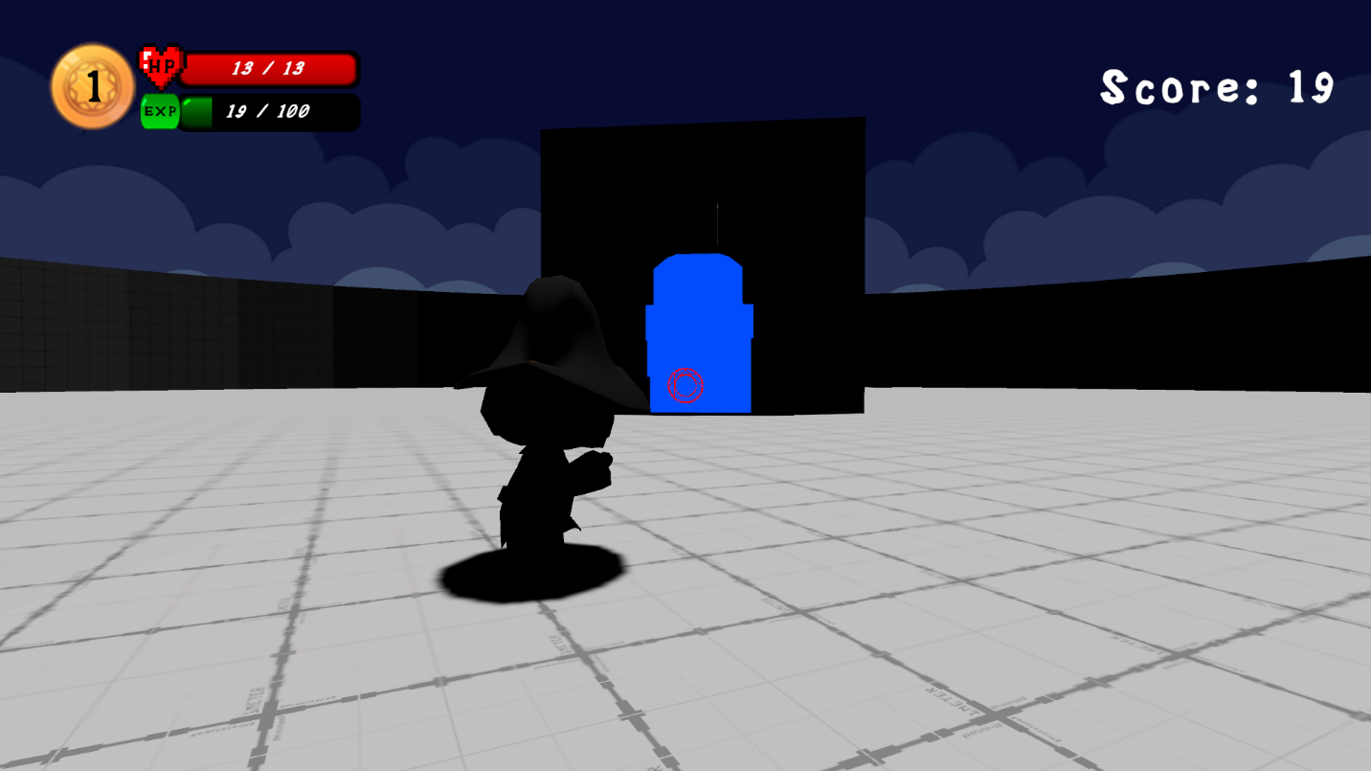

Once the player walks through this portal, they will be sent back to the rank/number selection screen where they can choose to fight more monsters with their recently upgraded stats:



Finally, once you defeat all of the monsters you will be taken to the final level:

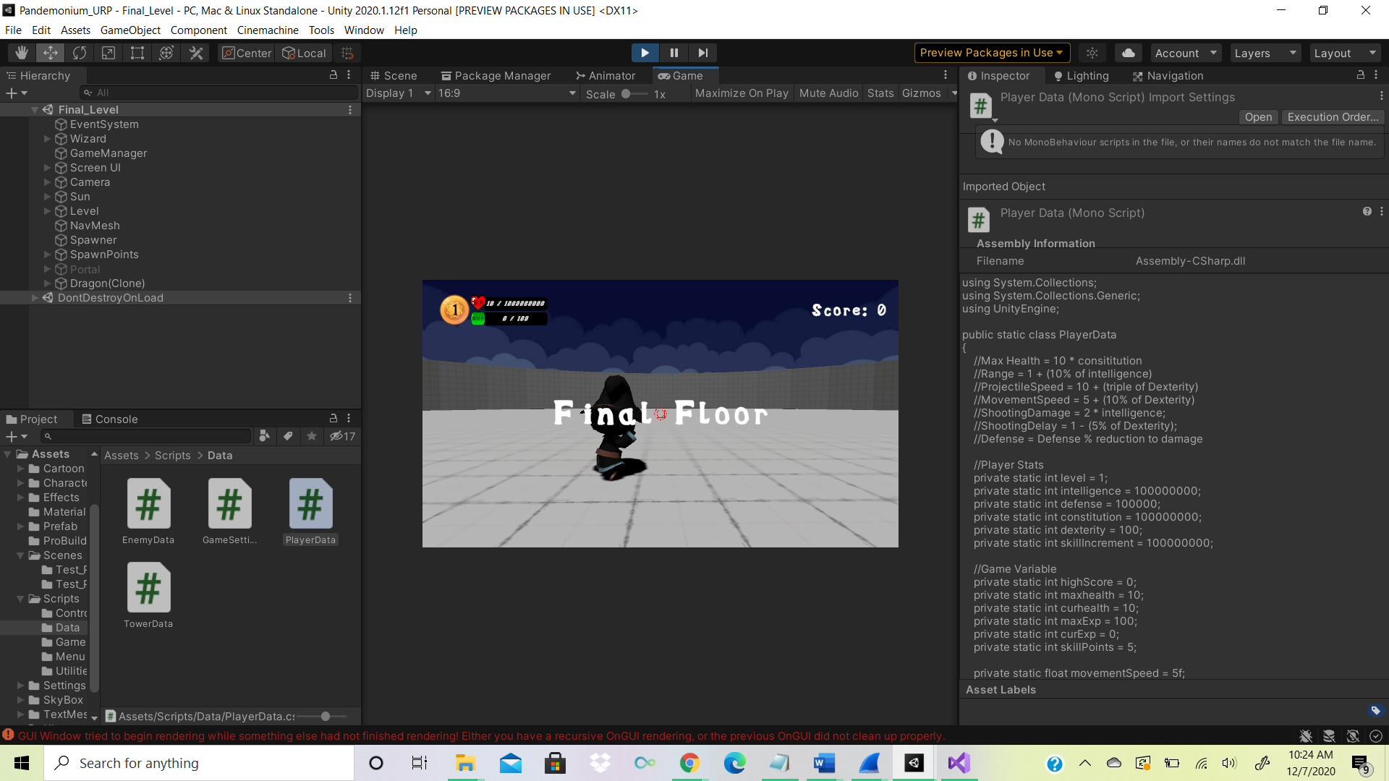

Here you will fight the final boss and only the final boss (picture of the final boss is not provided in order to avoid spoilers in the game instructions ☺)

Finally, when the final boss is defeated you will have won Pandemonium and will be presented with the final screen:

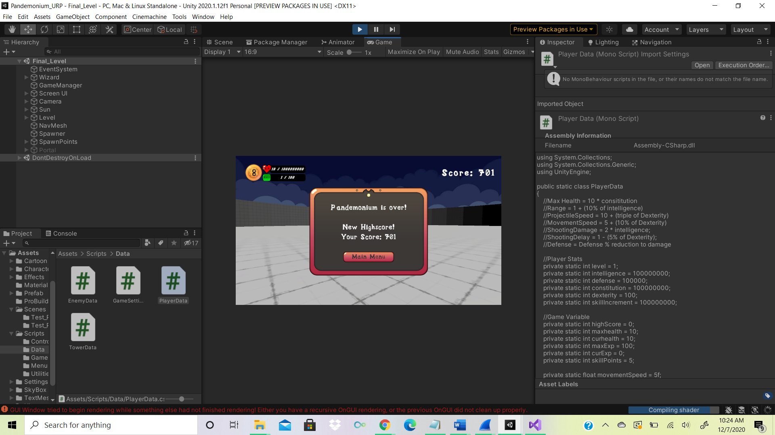

Congratulations!!! You now know how to play and beat Pandemonium! Have fun on your path to becoming an S-class mage. Make your friends proud!